**Annotation:** These are special labels/markers added to java classes. They provide meta-data about the class. These annotations have meanings, and checked at compile time.

For example:

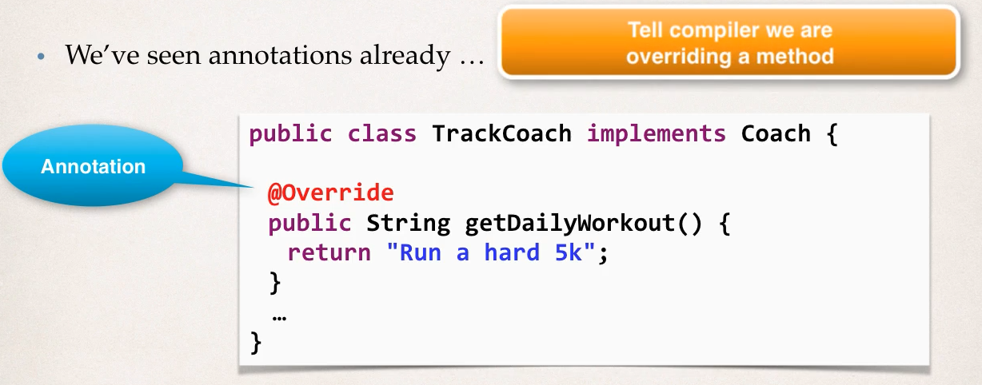

Compiler will verify if this override is actually correct or not, if not then it will not compile.

* In this system, it allows us to minimize the XML configurations.
* It will add metadata in our class and spring can use it to configure the beans and other stuff.
* What spring does is it scan all classes and register the bean when it is annoted.

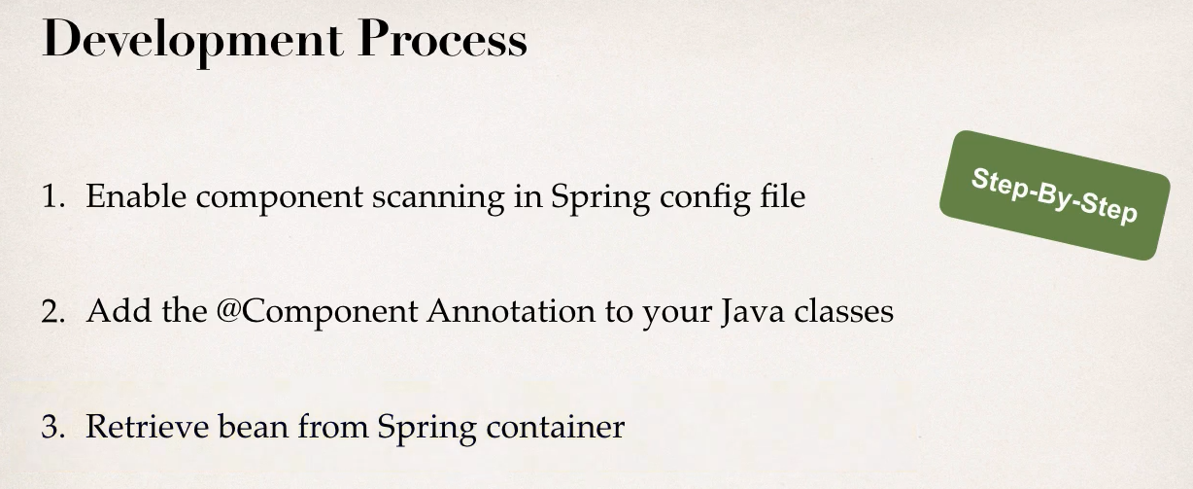

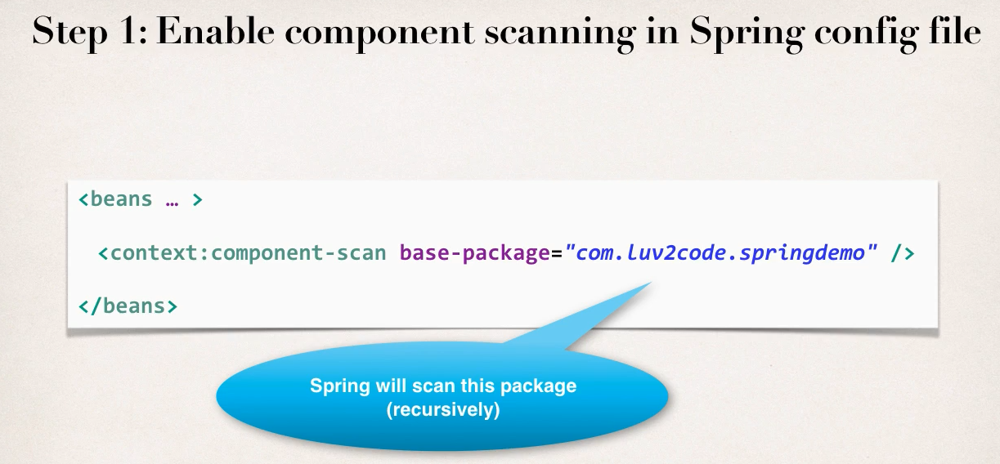

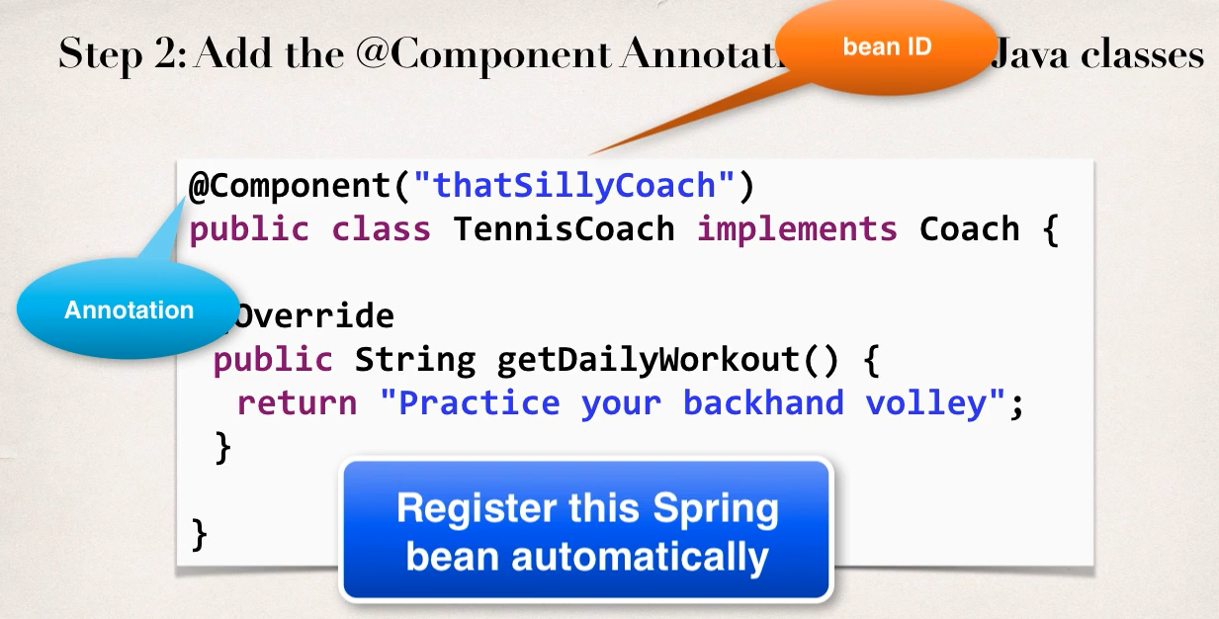

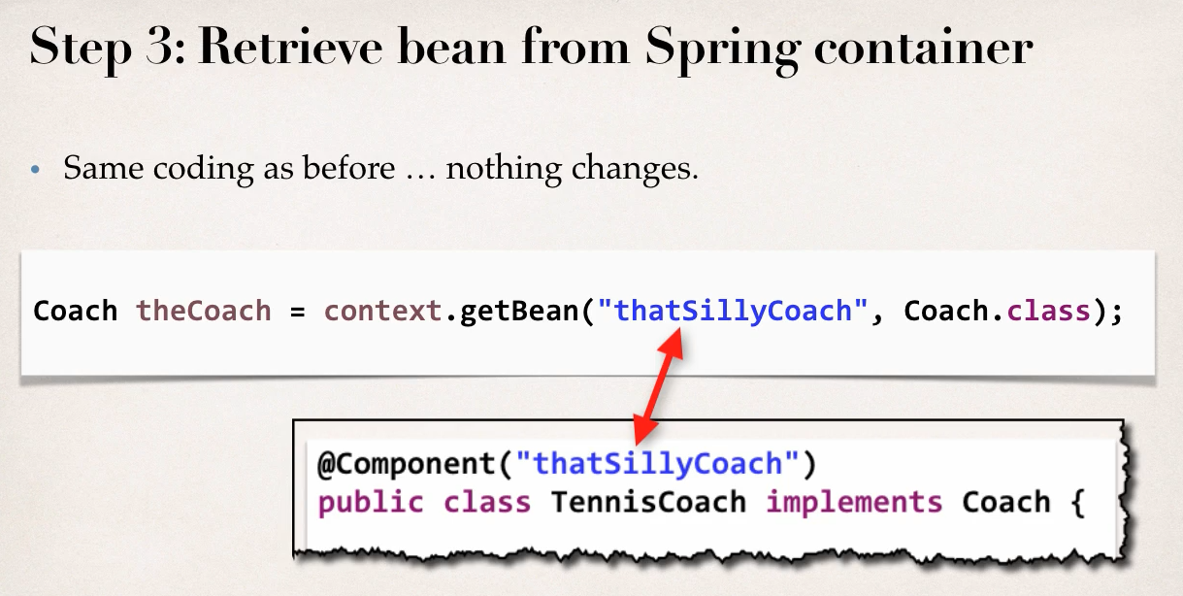

* If we don’t specify the bean id, spring will generate a default bean id with class name. But the starting letter will be lowercase.

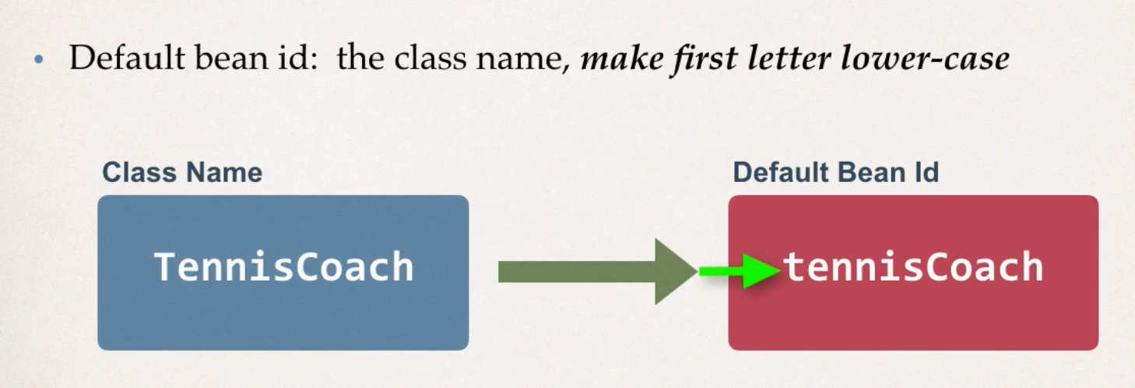

**Dependency Injections:** Spring automatically manage dependency injections in case of annotation. Here it will scan all the classes/interface that have @Components. When it finds, it will inject automatically.

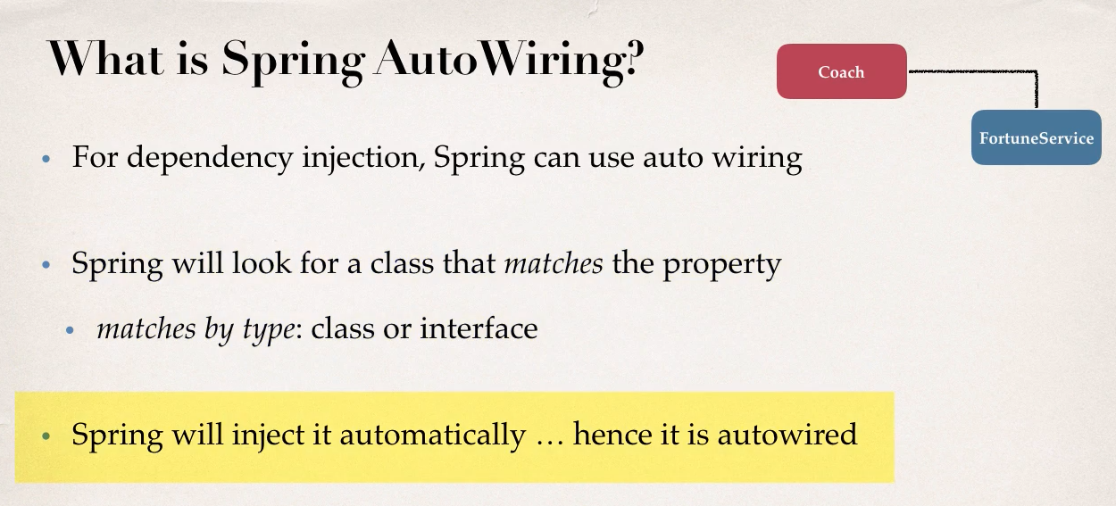

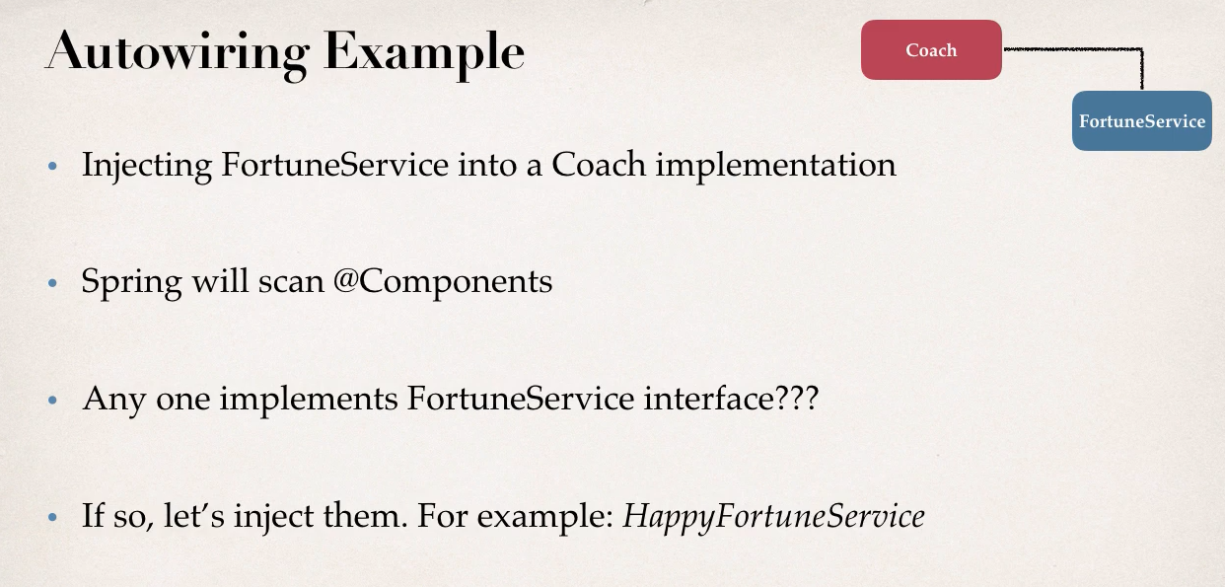

1. **Constructor Injection:** In this case, we can just add @Autowired annotation in the constructor, and spring will automatically manage the Dependency Injection

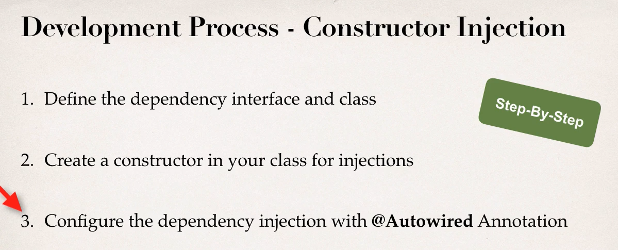

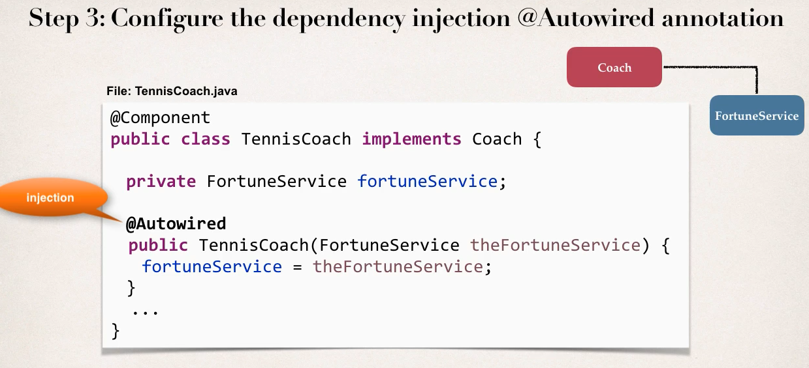

1. **Setter Injections:** Here, dependencies are injected by calling setter method(s) on the class. Very similar to constructor injection, just the @Autowired is annotation is used on the setter method instead of the constructor.

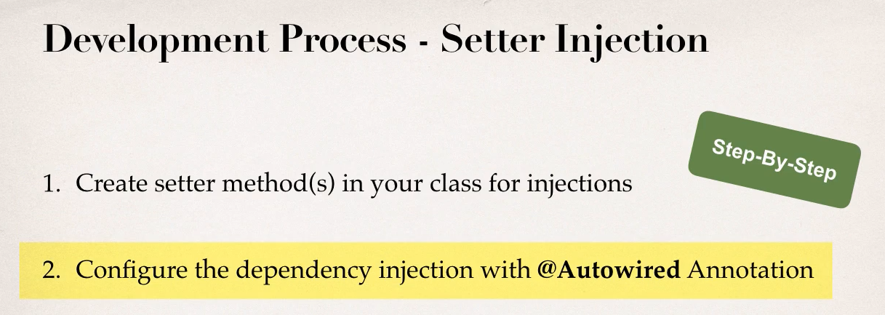

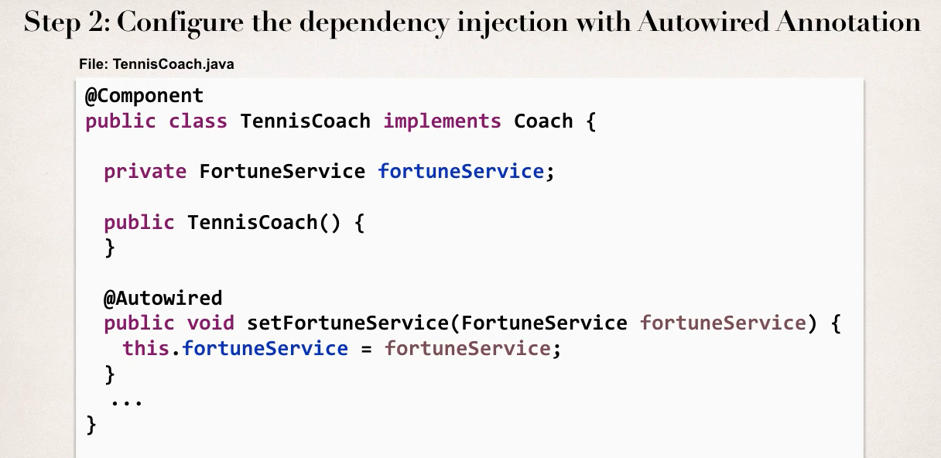

* 1. **Method Injections:** This process works on any method, not just setter. So, we can just @Autowired any method and spring will find dependency for that method.

1. **Field Injections:** Here, we actually don’t need any constructor or methods for dependency injection. We can just use @Autowired annotation in the field (works for even private fields) and spring will manage the dependency injections. It uses a Java technology called **Reflection**.

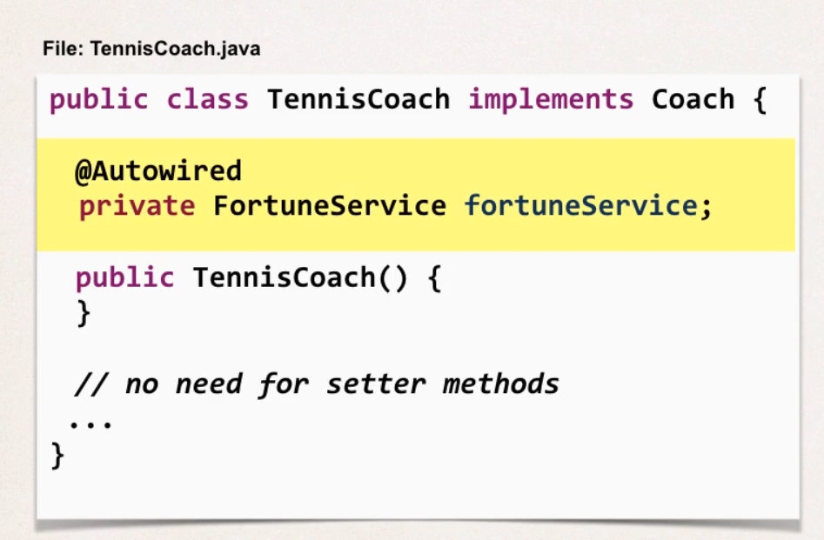

**Which one to choose?** All of them works same way, we can use any. It is just best to stay consistent, means use same way in whole project.

**Qualifier:** For annotations, spring search all the class with @Component. But if multiple classes implement same interface, then we have a problem. Then Spring will give us an error.

* **Solution:** In this case, we can use Qualifier to tell Spring which implementation to use. Inside the Annotation we give the bean id.

